

Course Project Report
Subject: SWD392

– Da Nang, April 2025 –

Table of Contents
Record of Changes 3
I. Overview 4
I.1 Project Information 4
I.2 Project Team 4
II. Requirement Specification 4
II.1 Problem description 4
II.2 Major Features 4
II.3 Context Diagram 4
II.4 Nonfunction Requirements 5
II.5 Functional requirements 5
II.5.1 Actors 5
II.5.2 Use Cases 5
II.5.2 .1 Diagram(s) 5
II.5.2.2 Use case descriptions 6
II.5.3 Activity diagram 8
III. Analysis models. 9
III.1 Interaction diagrams 9
III.2 State diagram 10
IV. Design specification 11
IV.1 Integrated Communication Diagrams 11
IV.2 System High-Level Design 11
IV.3 Component and Package Diagram 11
IV.4 Class diagram 12
IV.5 Database Design 12
V. Implementation 13
V.1 Map architecture to the structure of the project 13
V.2 Map Class Diagram and Interaction Diagram to Code 13
V. Applying Alternative Architecture Patterns 13
V.1 Applying the service-oriented architecture 13
V.2 Applying Service Discovery Pattern in the service-oriented architecture 13

Record of Changes
Date | A*  M, D | In charge | Change Description
21/5 | A | All Members | Add Actor, Complete Use Case Diagram
22/5 | A | All Members | Complete Feature descriptions
26/5 | A | All Members | Complete Activity diagram
28/5 | A | All Members | Complete Entity Relationship Diagram
*A - Added M - Modified D - Deleted

I. Overview

I.1 Project Information
- Project name: << Motorbike Rental Management System>>
- Project code: <<MOTOV>>
- Group name: <<SWD392-G3>>
- Software type: <<Software Type: Web, Mobile App,..>>

I.2 Project Team
Full Name | Role | Email | Mobile
 | Lecturer
Đặng Phương Khôi Nguyên | Leader | Nguyenstudy0504@gmail.com
Lê Thị Bảo Uyên | Member | Uyenltbde180515@fpt.edu.vn | 0366078587
Mai Xuân Tùng | Member | Tungmxde180507@fpt.edu.vn
Trần Quang Bửu Hoàng | Member | Hoangtqbde180962@fpt.edu.vn
Nguyễn Hà Tiến Quang | Member | Quang230805@gmail.com

II. Requirement Specification

II.1 Problem description
The Motorbike Rental Management System is a web-based platform developed to modernize and simplify the traditional motorbike rental process. Currently, many rental shops still manage bookings manually through phone calls, messaging applications, or paper records. This leads to several problems such as booking conflicts, inaccurate vehicle availability, difficulty in tracking rental history, delayed customer support, and inefficient business management.
The proposed system provides an online platform that allows customers to search for available motorbikes, compare prices, make reservations, complete payments, and track rental status conveniently. At the same time, rental shop administrators can manage vehicles, customer information, bookings, payments, maintenance schedules, and reports in a centralized system.
The system also improves customer experience by integrating smart features such as online payments, digital contracts, rental reminders, real-time availability updates, customer reviews, and GPS-supported vehicle tracking.
The context diagram below illustrates the interactions between the Motorbike Rental Management System and external entities including customers, administrators, payment gateways, notification services, and GPS tracking services.

External Entities
- Customer
- Administrator
- Rental Staff
- Payment Gateway
- Email/SMS Notification Service
- GPS Tracking Service

Main Data Flows
- Booking requests and confirmations
- Payment transactions
- Vehicle information updates
- Customer registration and authentication
- Rental notifications and reminders
- GPS location tracking data

II.2 Major Features

FE-01: User Registration and Authentication
Customers can register accounts, log in securely, reset passwords, and manage personal profiles.

FE-02: Motorbike Search and Booking
Customers can search available motorbikes based on type, location, price, brand, or rental duration and make reservations online.

FE-03: Online Payment Integration
The system supports secure online payment methods such as banking, e-wallets, and QR payments.

FE-04: Rental Order Management
Customers can create, view, modify, or cancel rental orders.

FE-05: Vehicle Management
Administrators can add, edit, delete, and manage motorbike information including status, pricing, maintenance history, and images.

FE-06: GPS Tracking and Vehicle Monitoring
The system supports GPS integration to help track rented motorbikes and improve security.

FE-07: Notification and Reminder System
Customers receive booking confirmations, payment receipts, rental reminders, and return notifications through email or SMS.

FE-08: Review and Rating System
Customers can rate motorbikes and leave feedback after completing rentals.

FE-09: Reporting and Analytics
Administrators can generate reports related to revenue, bookings, vehicle usage, and customer activity.

FE-10: Maintenance Management
The system tracks vehicle maintenance schedules and alerts administrators when maintenance is required.

II.3 Context Diagram

System: Motorbike Rental Management System

External Entities and Interactions
External Entity | Input to System | Output from System
Customer | Registration data, booking requests, payments, reviews | Booking confirmation, payment status, notifications
Administrator | Vehicle updates, pricing updates, report requests | Business reports, customer information
Rental Staff | Rental status updates, maintenance records | Rental schedules, customer booking details
Payment Gateway | Payment verification | Payment requests
Notification Service | Notification delivery status | Emails, SMS reminders
GPS Tracking Service | GPS location data | Tracking requests

Context Diagram Description
The Motorbike Rental Management System acts as the central platform connecting customers, administrators, staff, payment services, and GPS services. Customers interact with the system to search, book, and pay for rentals. Administrators and staff manage operational activities while external services support payments, notifications, and tracking.

II.4 Nonfunctional requirements
# | Feature | System Function | Description
1 | Authentication | Login Service | Validate user credentials securely using encrypted passwords and session management.
2 | Booking Management | Booking API | Handle booking requests and ensure real-time vehicle availability updates.
3 | Payment Processing | Payment Gateway Integration | Process secure online transactions and payment verification.
4 | Notification System | Email/SMS Service | Automatically send booking confirmations and reminders.
5 | GPS Tracking | Vehicle Tracking Service | Track vehicle locations in real time for security purposes.
6 | Reporting | Report Generation Service | Generate monthly revenue and booking statistics.
7 | Maintenance | Maintenance Scheduler | Automatically remind administrators about vehicle maintenance schedules.
8 | Performance | Load Handling | Support multiple concurrent users without major performance degradation.
9 | Security | Data Protection | Protect user information and transaction data using encryption and authentication mechanisms.
10 | Backup | Data Backup Service | Automatically back up system data daily to prevent data loss.

II.5 Functional requirements

II.5.1 Actors
# | Actor | Description
1 | Guest | Unregistered user who can browse the website, search motorbikes, and view vehicle information without logging in.
2 | Customer | Registered user who can book motorbikes, make payments, manage bookings, and submit reviews.
3 | Admin | Manages the entire system including users, vehicles, reports, and platform settings. Admin is a specialized role of Customer.
4 | Owner | Manages rental shop information, motorbike inventory, pricing, and rental operations. Owner is a specialized role of Customer.
5 | Staff | Supports daily rental activities such as confirming bookings, checking vehicle conditions, and handling returns. Staff is a specialized role of Customer.

II.5.2 Use Cases

Guest Use Cases
- Register Account
- Login
- Search Motorbike
- View Motorbike Details
- View Rental Prices

Customer Use Cases
- Manage Profile
- Book Motorbike
- Make Payment
- View Booking History
- Cancel Booking
- Submit Review
- Receive Notifications

Admin Use Cases
- Manage Users
- Manage System Settings
- Manage Reports
- Monitor Activities
- Manage Categories

Owner Use Cases
- Manage Motorbike Inventory
- Approve Booking Requests
- Manage Maintenance Schedule
- View Revenue Reports

Staff Use Cases
- Confirm Booking
- Deliver Motorbike
- Receive Returned Vehicle
- Update Rental Status
- Support Customers

II.5.2 .1 Diagram(s)

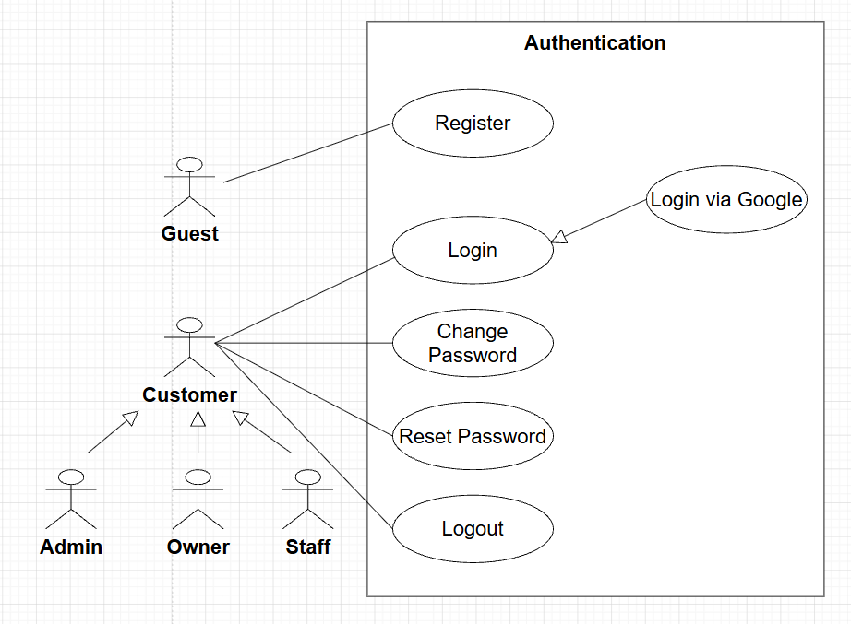
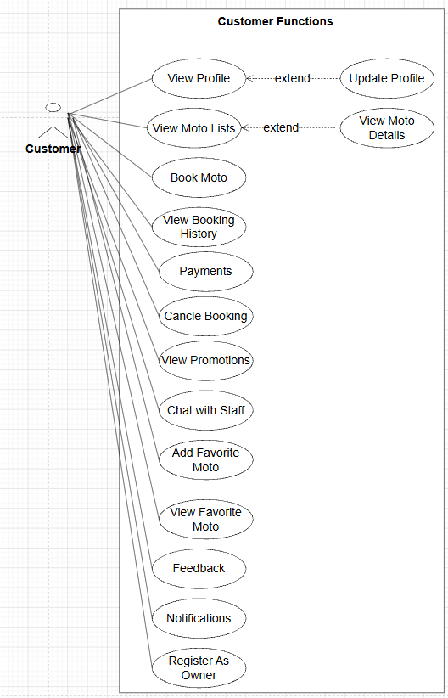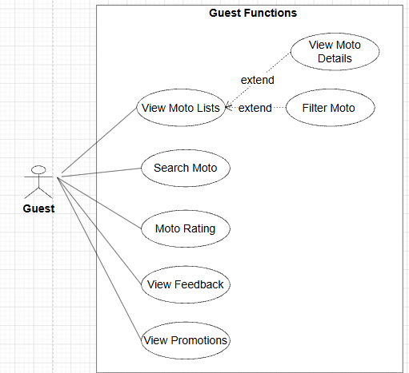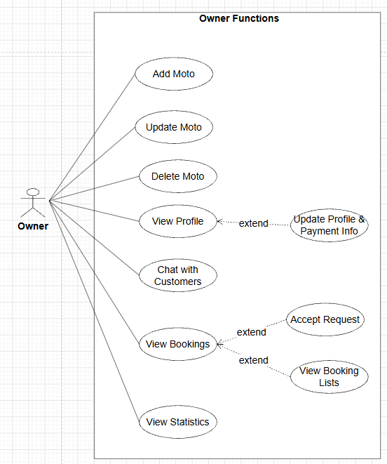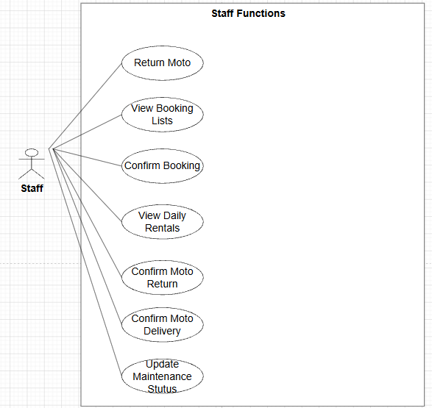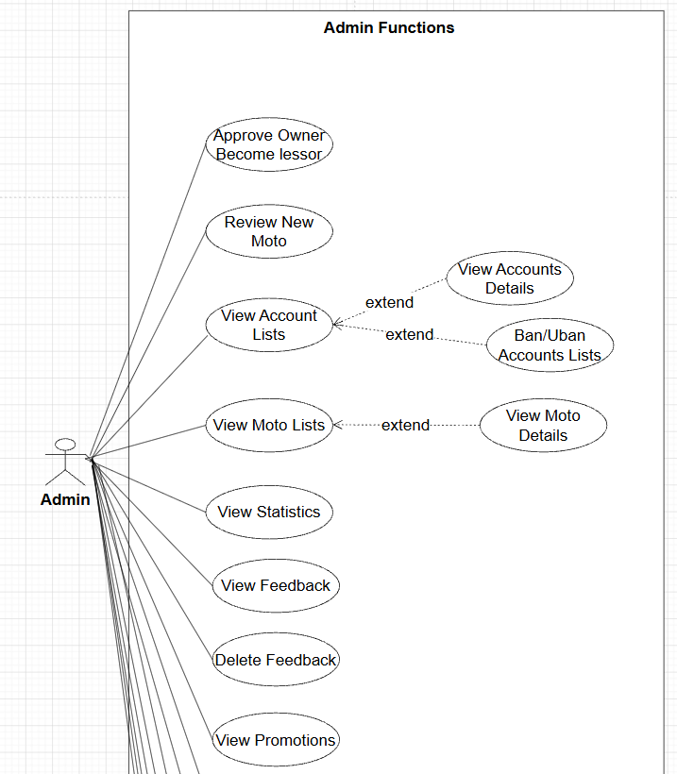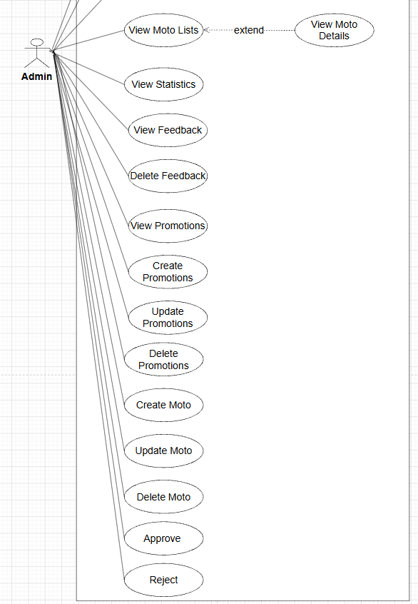

II.5.2.2 Use case descriptions
This part describes the use cases, you can follow the table form as below]
ID | Use Case | Actors | Use Case Description
UC-01 | Register Account | Guest | Guest creates a new account to access the rental system.
UC-02 | Login | Guest, Customer, Admin, Owner, Staff | Users authenticate and access system functions based on their roles.
UC-03 | Search Motorbike | Guest, Customer | Users search motorbikes by category, price, location, or availability.
UC-04 | View Motorbike Details | Guest, Customer | Users view detailed information, images, and rental prices of motorbikes.
UC-05 | Book Motorbike | Customer | Customer books a motorbike for a selected rental duration.
UC-06 | Make Payment | Customer | Customer pays rental fees through supported online payment methods.
UC-07 | Cancel Booking | Customer | Customer cancels an existing booking before the rental start time.
UC-08 | Submit Review | Customer | Customer rates and reviews completed rental services.
UC-09 | Manage Users | Admin | Admin manages user accounts, permissions, and account status.
UC-10 | Manage Reports | Admin | Admin monitors business reports and system statistics.
UC-11 | Manage Categories | Admin | Admin manages motorbike categories and rental policies.
UC-12 | Manage Motorbike Inventory | Owner | Owner adds, edits, deletes, and updates motorbike information.
UC-13 | Approve Booking Requests | Owner | Owner reviews and approves customer rental requests.
UC-14 | Manage Maintenance Schedule | Owner | Owner manages vehicle maintenance and repair schedules.
UC-15 | View Revenue Reports | Owner | Owner tracks rental income and booking performance.
UC-16 | Confirm Booking | Staff | Staff verifies customer booking information before rental delivery.
UC-17 | Deliver Motorbike | Staff | Staff hands over the motorbike to the customer.
UC-18 | Receive Returned Vehicle | Staff | Staff checks vehicle condition when customers return motorbikes.
UC-19 | Update Rental Status | Staff | Staff updates rental progress and vehicle availability status.
UC-20 | Support Customers | Staff | Staff assists customers during the rental process.

Functional Description Template
1 <<UC-01 Register Account>>
UC ID and Name: | UC-01 Register Account
Created By: | Bao Uyen | Date Created: | 22/05/2026
Primary Actor: | Guest | Secondary Actors: | System
Trigger: | Guest selects the “Register” function
Description: | Guest creates a new account to access the motorbike rental system.
Preconditions: | Guest has not registered before.
Postconditions: | A new customer account is successfully created and stored in the system database.
Normal Flow: | 1. Guest opens registration page.  2. System displays registration form.  3. Guest enters personal information.  4. Guest submits the form.  5. System validates information.  6. System encodes password using MD5.  7. System creates new account successfully.
Alternative Flows: | 3a. Guest enters invalid email format → System requests correction.
Exceptions: | 6a. Email already exists → Registration fails.
Priority: | High – Must Have
Frequency of Use: | High
Business Rules: | FR1 – Password Encoding
Other Information: | Registration confirmation email may be sent.
Assumptions: | Guest has internet connection and valid email address.

b. Business Rules
Provide the business rules those are applied only to the use case
ID | Business Rule | Business Rule Description
BR1.1 | Password Encoding | User passwords must be encrypted using MD5 hashing before storing in the database
BR1.2 | Unique Email | Each registered email address must be unique in the system.
BR1.3 | Mandatory Registration Information | Users must provide required personal information during registration.

2 <<UC-02 Login>>
UC ID and Name: | UC-02 – Login
Created By: | Bao Uyen | Date Created: | 22/05/2026
Primary Actor: | Guest | Secondary Actors: | Customer, Admin, Owner, Staff
Trigger: | User selects “Login”
Description: | Users authenticate and access the system based on assigned roles.
Preconditions: | User account already exists.
Postconditions: | User successfully logs into the system.
Normal Flow: | 1. User opens login page.  2. User enters email and password.  3. System validates credentials.  4. System grants access based on role.
Alternative Flows: | 2a. User forgets password → System redirects to reset password page.
Exceptions: | 3a. Invalid credentials → Login fails.
Priority: | High – Must Have
Frequency of Use: | Very High
Business Rules: | FR1 – Password Encoding
Other Information: | Session timeout after inactivity.
Assumptions: | User remembers account credentials.

b. Business Rules
Provide the business rules those are applied only to the use case
ID | Business Rule | Business Rule Description
BR2.1 | Role-Based Access Control | System functions must be accessible according to user roles.
BR2.2 | Account Authentication | Users must enter valid credentials to access the system.
BR2.3 | Account Status Validation | Suspended or inactive accounts cannot log into the system.

5 <<UC-05 Book Motorbike>>
UC ID and Name: | UC-05 – Book Motorbike
Created By: | Bao Uyen | Date Created: | 22/05/2026
Primary Actor: | Customer | Secondary Actors: | System, Owner
Trigger: | Customer selects a motorbike and clicks “Book Now”
Description: | Customer books a motorbike for a selected rental period.
Preconditions: | Customer is logged in and selected motorbike is available.
Postconditions: | Booking request is recorded in the system.
Normal Flow: | 1. Customer selects motorbike.  2. Customer chooses rental duration.  3. System calculates rental cost.  4. Customer confirms booking.  5. System stores booking request.
Alternative Flows: | 2a. Customer changes rental dates → System recalculates cost.
Exceptions: | 1a. Motorbike unavailable → Booking rejected.
Priority: | High – Must Have
Frequency of Use: | High
Business Rules: | Customer must pay before rental confirmation.
Other Information: | Booking confirmation notification is sent.
Assumptions: | Customer provides correct booking information.

b. Business Rules
Provide the business rules those are applied only to the use case
ID | Business Rule | Business Rule Description
BR5.1 | Booking Eligibility | Only registered and logged-in customers can make bookings.
BR5.2 | Booking Availability Validation | Customers cannot book unavailable or maintenance vehicles.
BR5.3 | Rental Duration Validation | Rental start date must be earlier than return date.
BR5.4 | Automatic Rental Cost Calculation | System automatically calculates rental fees based on rental duration and bike price.

6 <<UC-06 Make Payment>>
UC ID and Name: | UC-06 Make Payment
Created By: | Bao Uyen | Date Created: | 22/05/2026
Primary Actor: | Customer | Secondary Actors: | Payment Gateway, System
Trigger: | Customer selects payment method
Description: | Customer pays rental fees through online payment methods.
Preconditions: | Booking request exists.
Postconditions: | Payment transaction is completed successfully.
Normal Flow: | 1. Customer selects payment method.  2. System redirects to payment gateway.  3. Customer confirms payment.  4. Payment gateway processes transaction.  5. System updates booking status.
Alternative Flows: | 3a. Customer cancels payment process.
Exceptions: | 4a. Payment transaction fails.
Priority: | High – Must Have
Frequency of Use: | High
Business Rules: | Payment must be completed before rental approval.
Other Information: | System supports online banking and e-wallet payment.
Assumptions: | Payment gateway service is available.

b. Business Rules
Provide the business rules those are applied only to the use case
ID | Business Rule | Business Rule Description
BR6.1 | Online Payment Requirement | Customers must complete payment before booking approval.
BR6.2 | Supported Payment Methods | System supports approved online payment methods only.
BR6.3 | Payment Verification | Booking status changes only after successful payment confirmation.

9 <<UC-09 Manage Users>>
UC ID and Name: | UC-09 Manage Users
Created By: | Bao Uyen | Date Created: | 22/05/2026
Primary Actor: | Admin | Secondary Actors: | System
Trigger: | Admin opens user management dashboard
Description: | Admin manages user accounts and permissions.
Preconditions: | Admin is logged into the system.
Postconditions: | User information is updated successfully.
Normal Flow: | 1. Admin views user list.  2. Admin selects user account.  3. Admin edits account information or permissions.  4. System saves updates.
Alternative Flows: | 2a. Admin searches specific users.
Exceptions: | 4a. System fails to save updates.
Priority: | Medium – Should Have
Frequency of Use: | Medium
Business Rules: | Only Admin can manage user permissions.
Other Information: | User activity logs are recorded.
Assumptions: | Admin has sufficient privileges.

B. Business Rules
Provide the business rules those are applied only to the use case
ID | Business Rule | Business Rule Description
BR9.1 | User Management Authorization | Only Admin can manage user accounts and permissions.
BR9.2 | Account Status Management | Admin can activate, suspend, or deactivate accounts.
BR9.3 | User Activity Logging | User management actions must be recorded in system logs.

II.5.3 Activity diagram
- Đăng ký tài khoản (Register Account)

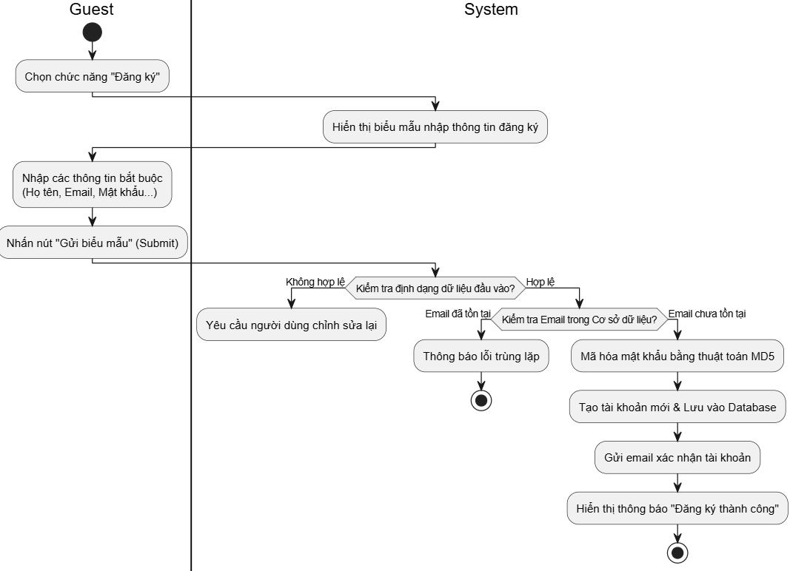

- Đặt xe & Thanh toán trực tuyến
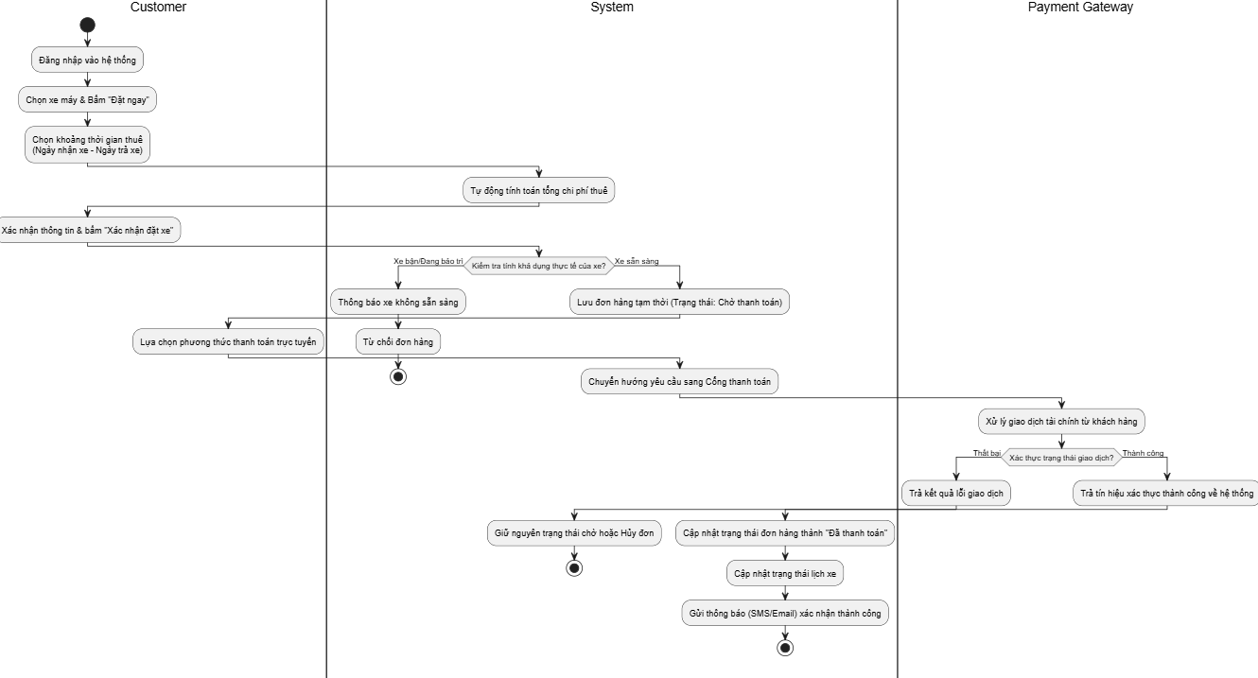
- Đăng nhập (Login)
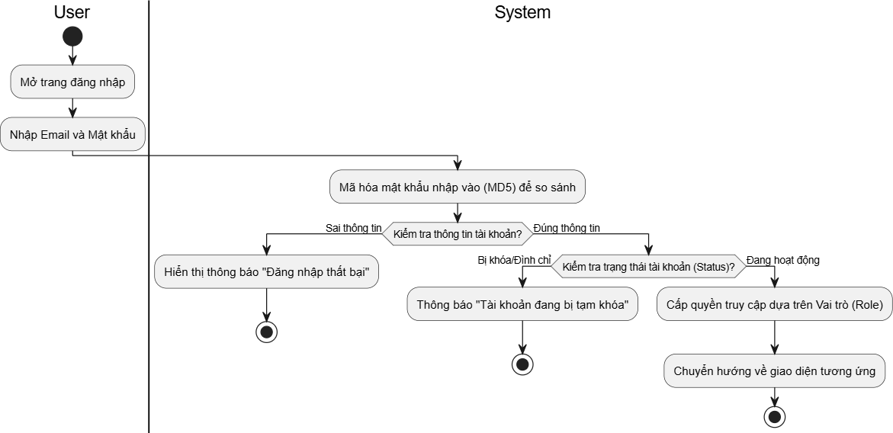
- Tìm kiếm xe máy (Search Motorbike)
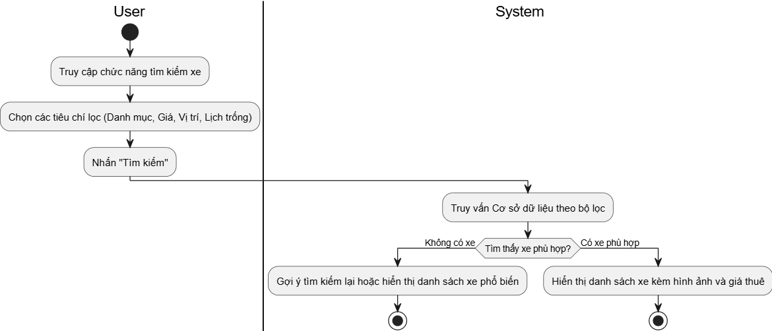
- Hủy đặt xe (Cancel Booking)
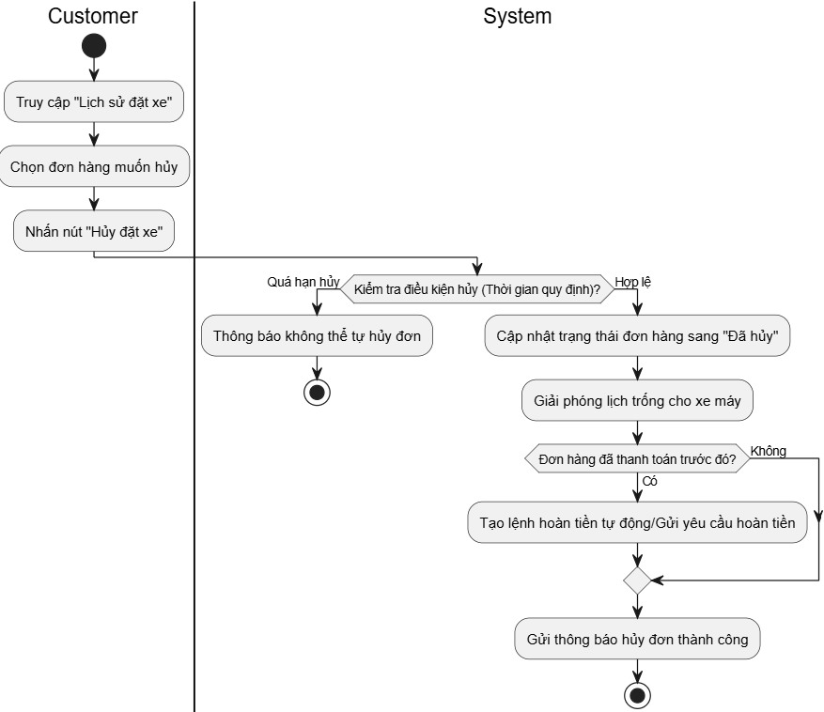
- Nhận xe khách trả (Receive Returned Vehicle)
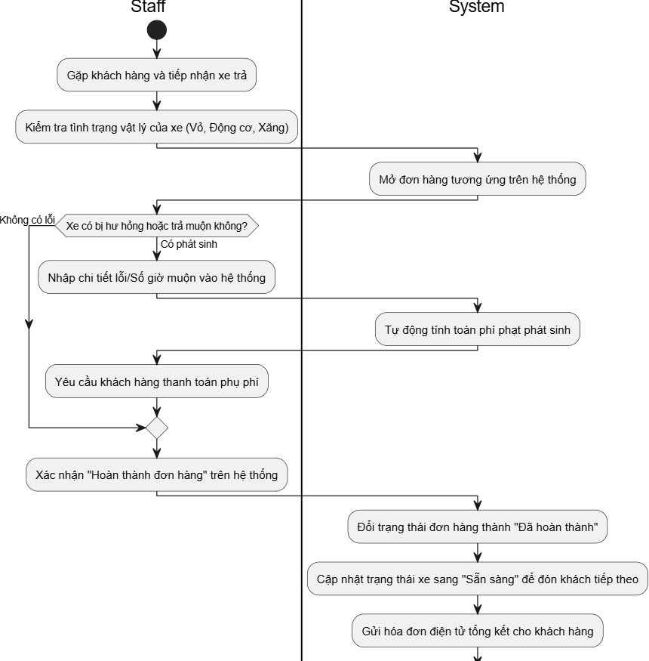
- Xem chi tiết xe máy (View Motorbike Details)
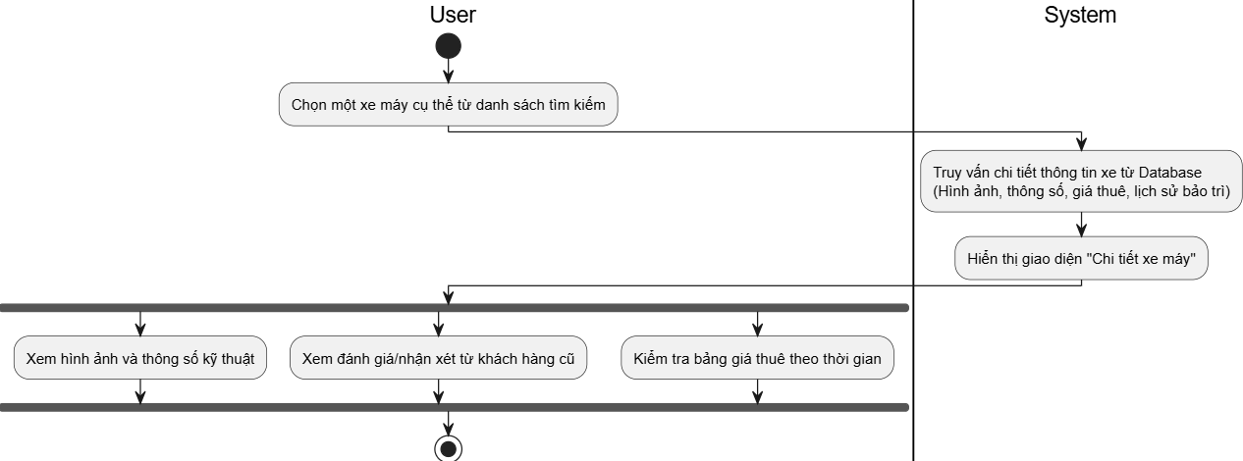
- Gửi đánh giá và phản hồi (Submit Review)
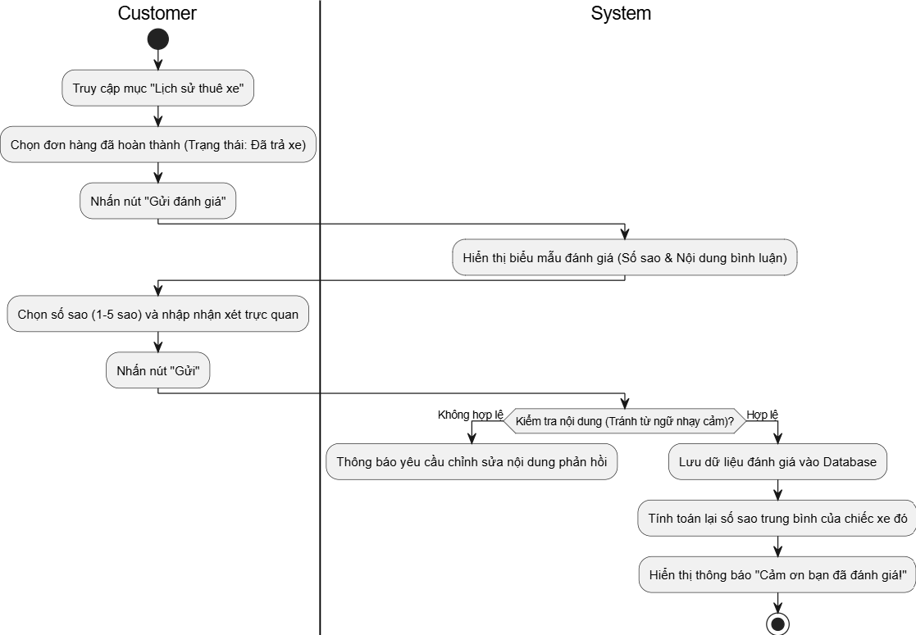
- Duyệt yêu cầu đặt xe (Approve Booking Requests)
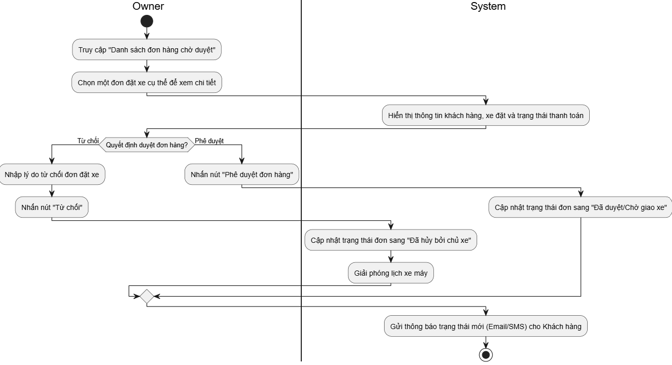
- Quản lý lịch bảo trì xe (Manage Maintenance Schedule)
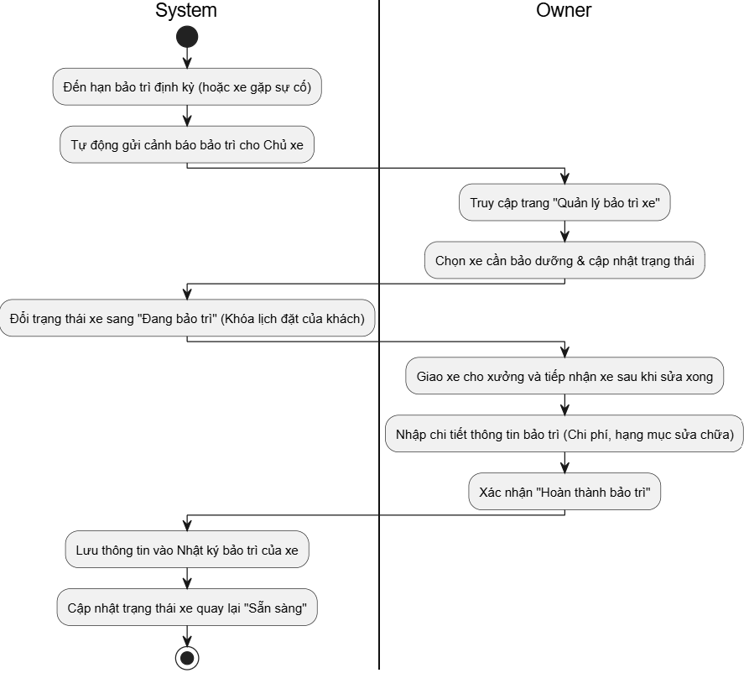
- Giao xe máy cho khách (Deliver Motorbike)
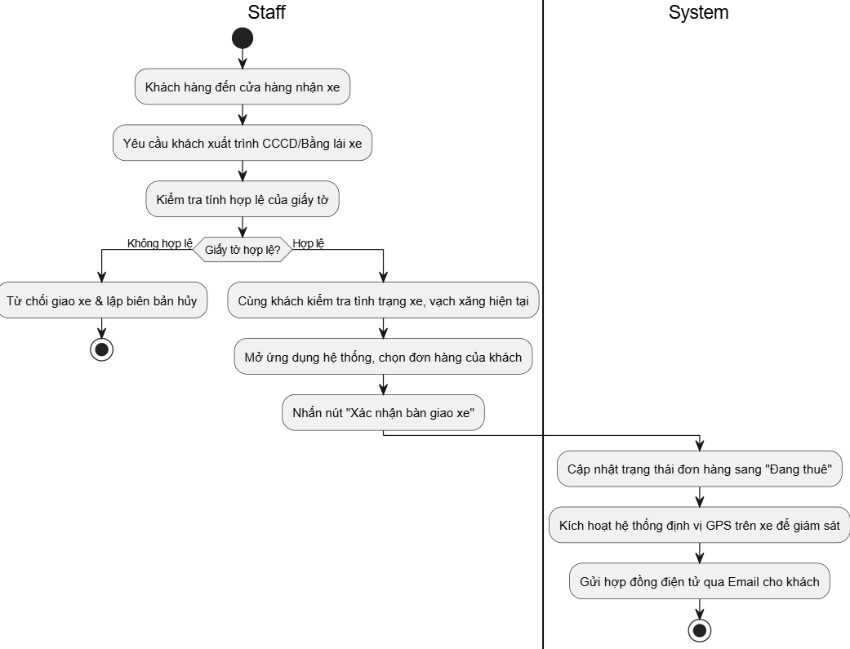
- Quản lý và xem báo cáo (Manage Reports)
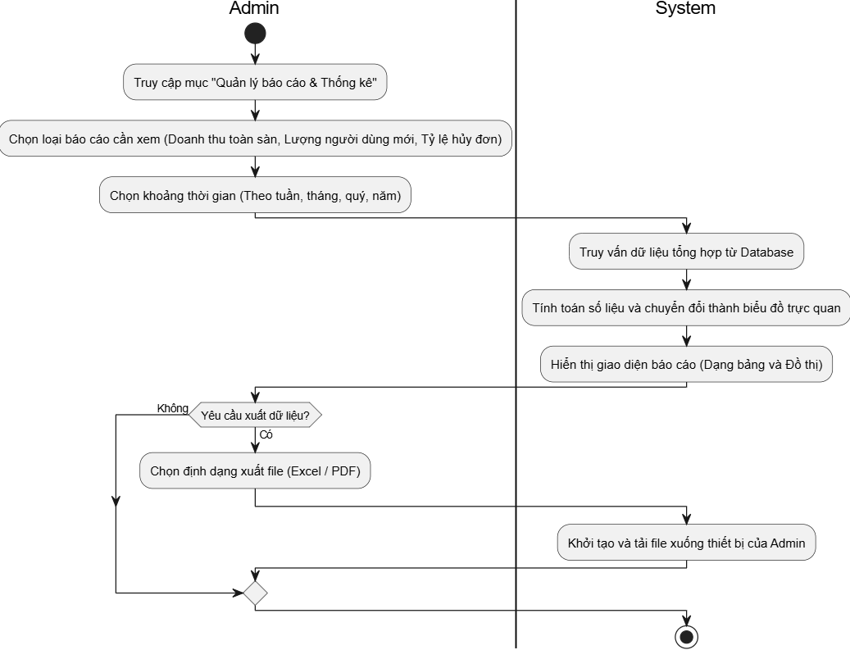
- Xem báo cáo doanh thu của Chủ xe (View Revenue Reports)
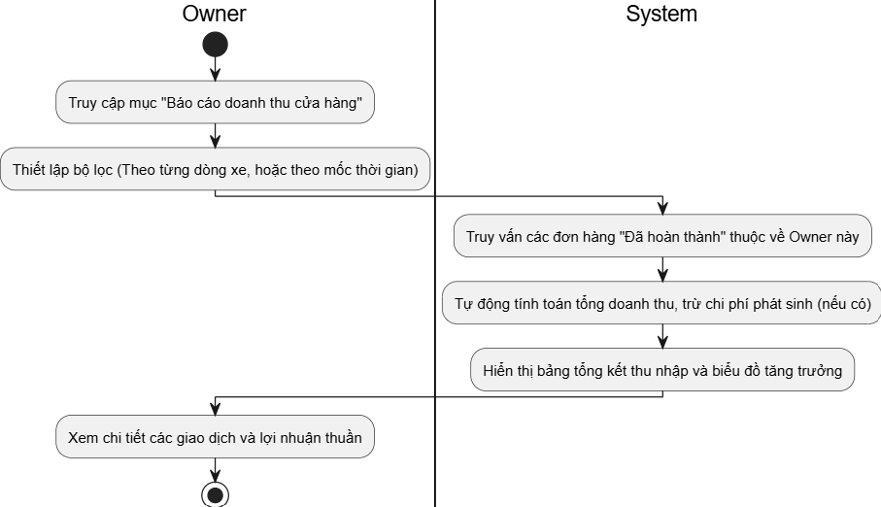
- Xác nhận thông tin đơn đặt xe (Confirm Booking)
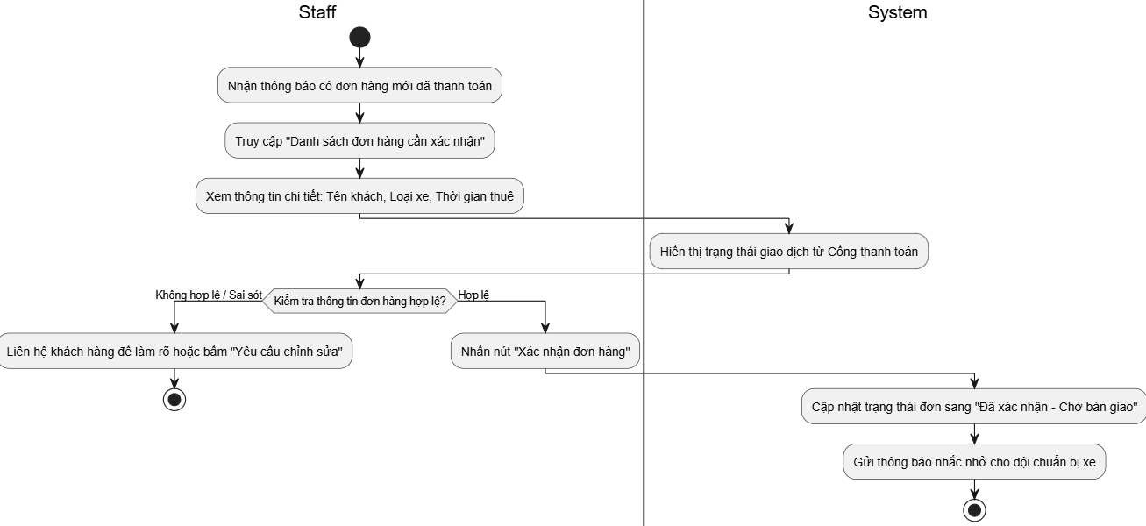
- Cập nhật trạng thái xe và đơn hàng (Update Rental Status)
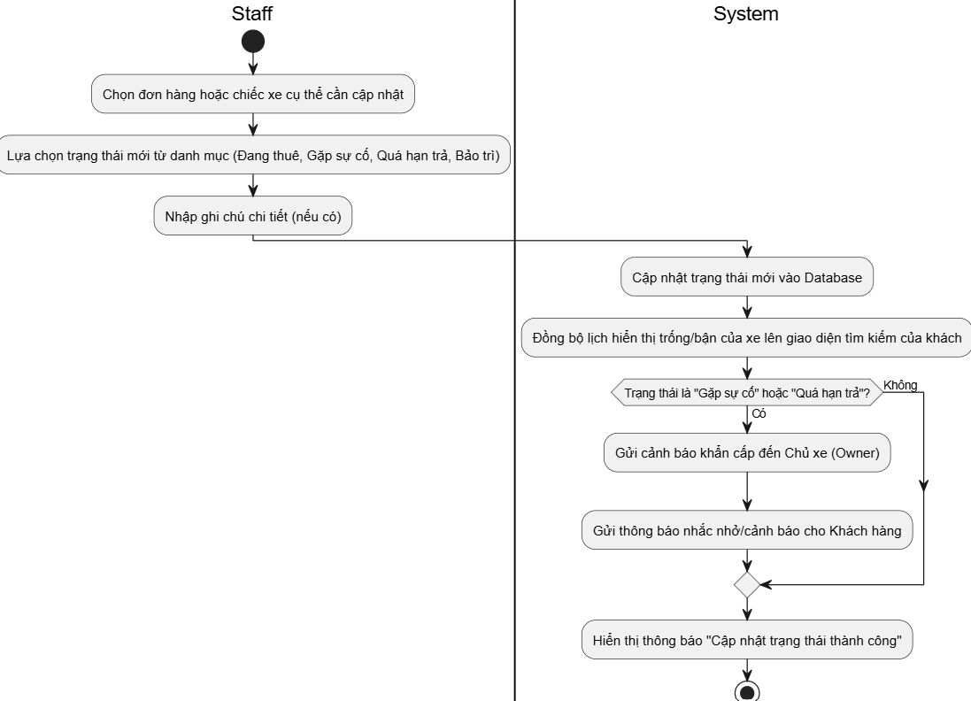
- Hỗ trợ khách hàng (Support Customers)
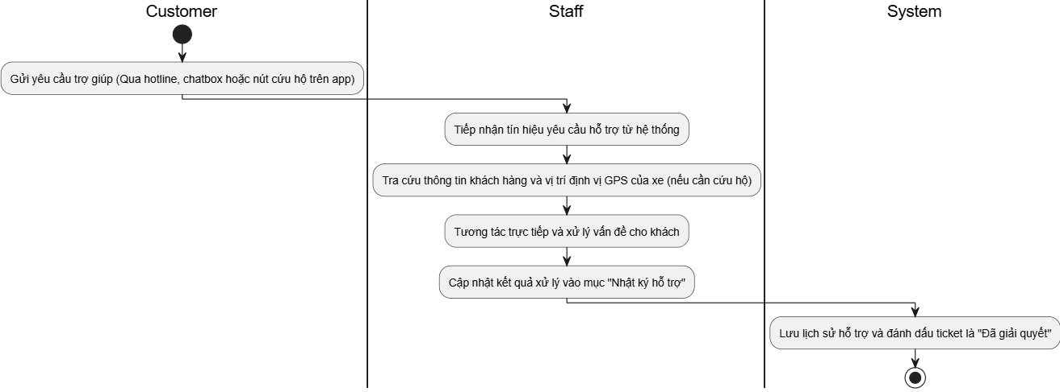

II.6 Entity Relationship Diagram

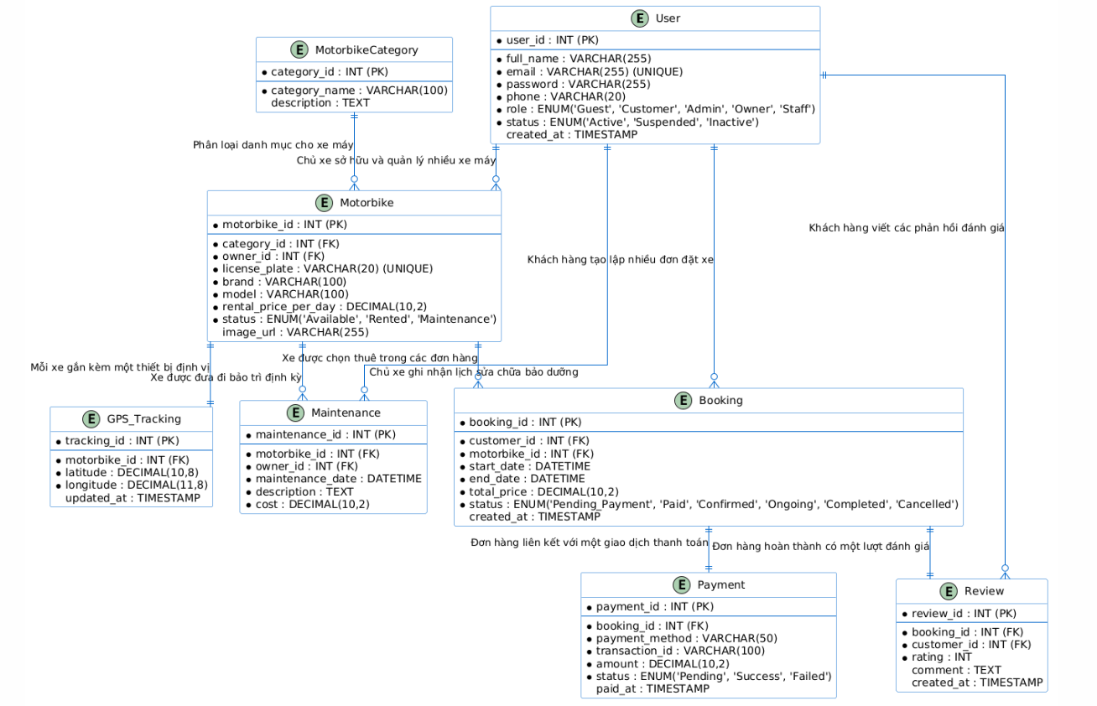
STT | Tên thực thể (Entity) | Mô tả vai trò nghiệp vụ (Description) | Các thuộc tính cốt lõi (Core Attributes)
1 | User | Quản lý toàn bộ thông tin định danh và tài khoản đăng nhập của các nhóm đối tượng tương tác với hệ thống (Customer, Admin, Owner, Staff). | user_id (PK), full_name, email, password, role, status.
2 | MotorbikeCategory | Phân loại các nhóm xe máy hiện có trong hệ thống (như Xe ga, Xe số, Xe phân khối lớn...) phục vụ tính năng lọc tìm kiếm của khách. | category_id (PK), category_name, description.
3 | Motorbike | Lưu trữ dữ liệu kỹ thuật, đơn giá thuê theo ngày, trạng thái thực tế và hình ảnh trực quan của từng phương tiện thuộc kho xe. | motorbike_id (PK), category_id (FK), owner_id (FK), license_plate, rental_price_per_day, status.
4 | Booking | Quản lý vòng đời và thông tin chi tiết của đơn đặt xe từ lúc khách thiết lập thời gian thuê cho đến khi trả xe hoàn tất. | booking_id (PK), customer_id (FK), motorbike_id (FK), start_date, end_date, total_price, status.
5 | Payment | Ghi nhận chi tiết lịch sử các giao dịch tài chính trực tuyến, mã giao dịch từ cổng thanh toán liên kết ứng với mỗi đơn đặt xe. | payment_id (PK), booking_id (FK), payment_method, transaction_id, amount, status.
6 | Review | Lưu trữ các phản hồi, nội dung bình luận phản hồi và mức độ hài lòng (số sao) của khách hàng sau khi trải nghiệm dịch vụ thuê xe. | review_id (PK), booking_id (FK), customer_id (FK), rating, comment.
7 | Maintenance | Lưu lại lịch sử, nhật ký sửa chữa, chi phí vật tư và các cảnh báo thời gian bảo dưỡng định kỳ của xe máy. | maintenance_id (PK), motorbike_id (FK), owner_id (FK), maintenance_date, cost, description.
8 | GPS_Tracking | Lưu trữ dữ liệu tọa độ địa lý (kinh độ, vĩ độ) thời gian thực từ thiết bị trên xe nhằm mục đích giám sát an toàn phương tiện. | tracking_id (PK), motorbike_id (FK), latitude, longitude, updated_at.

III. Analysis models.

III.1 Interaction diagrams
[Interaction diagrams are a type of UML diagram that illustrate how objects interact in a particular scenario of a use case. They focus on the flow of messages between objects or components over time.
There are two main types:
- Sequence Diagram – Emphasizes the time-ordering of messages
- Communication Diagram – Emphasizes the structure and relationships between objects]

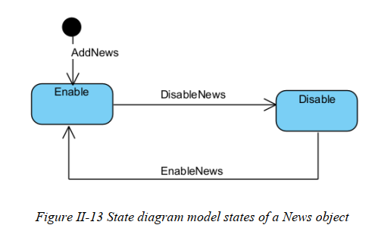

IV. Design specification

IV.1 Integrated Communication Diagrams
Sample
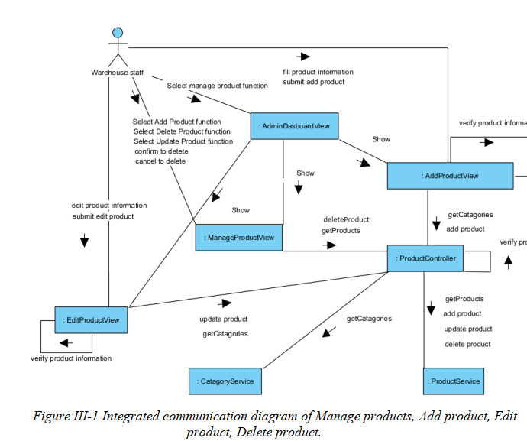

IV.2 System High-Level Design
Sample
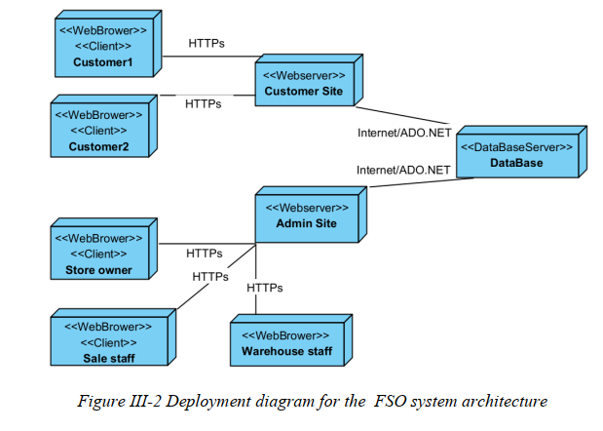

IV.3 Component and Package Diagram

IV.3.1 Component Diagram
Sample
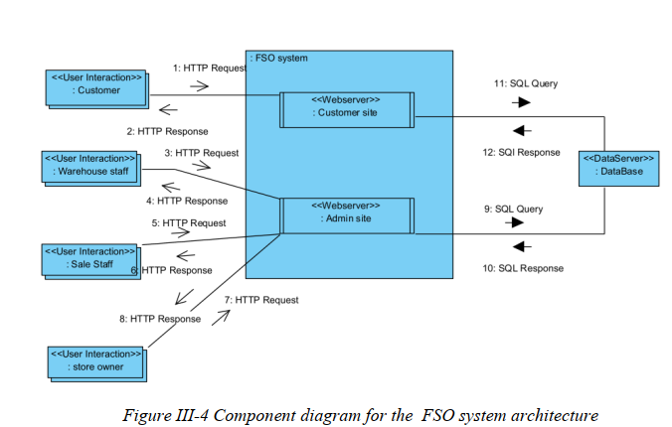

IV.3.1 . Package Diagram
[Provide the package diagram for each sub-system. The content of this section including the overall package diagram, the explanation, package and class naming conventions in each package. Please see the sample & description table format below (please note: package names don’t follow Java package naming convention yet)]
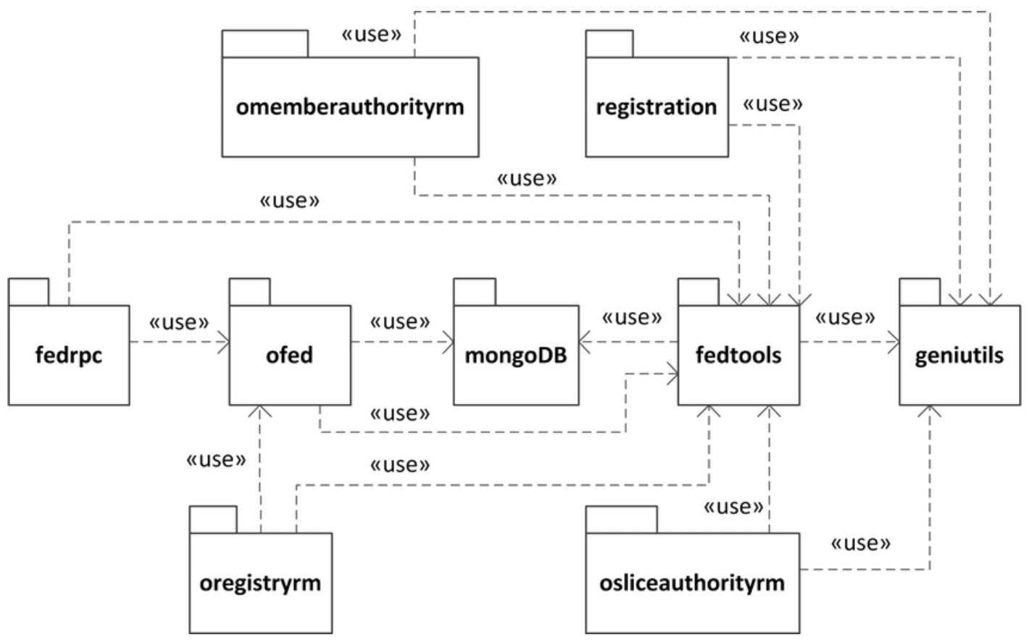
Package descriptions
No | Package | Description
01 | omemberauthorityrm | <Description of the package>
02 | registration | <Description of the package>
03 | fedrpc | <Description of the package>
04 | ofed | <Description of the package>
05 | mongoDB | <Description of the package>
06 | fedtools | <Description of the package>
07 | …

IV.4 Class diagram
[This part presents the class diagram for the relevant feature]
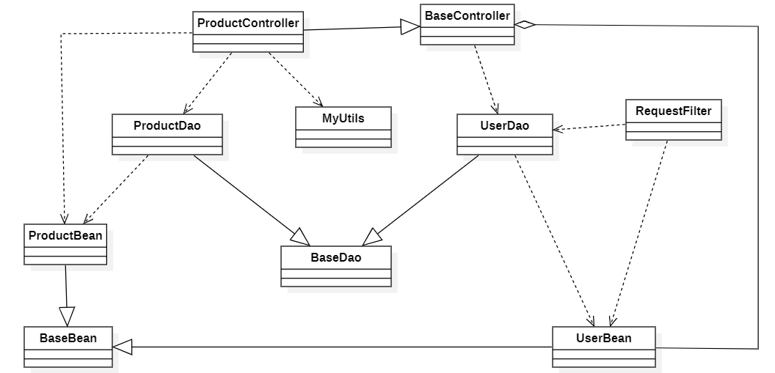

III.1.1.Sequence Diagram

[Provide the sequence diagram(s) for the feature, see the sample below]
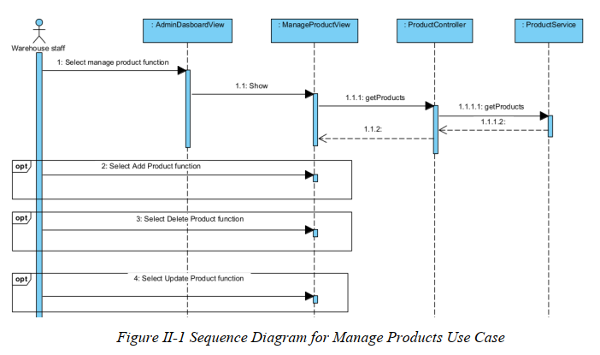

III.1.2. Communication Diagram
[Provide the Communication diagram(s) for the feature, see the sample below]

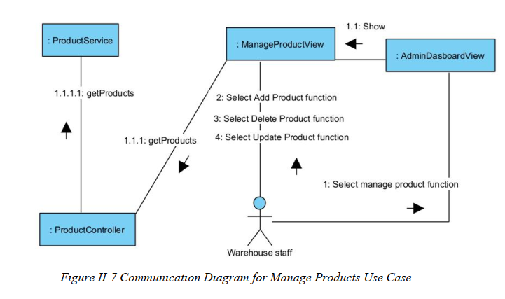

III.2 State diagram
[Provide the State diagram(s) for the feature, see the sample below]

IV.5 Database Design
[Provide the tables relationship like example below – following MySQL database naming convention]

V. Implementation

V.1 Map architecture to the structure of the project
[Provide:
- Overview of the Chosen Architecture
Briefly describe the architectural style (e.g., Layered, MVC, Service-Oriented Architecture)
Explain why it was selected for this project (e.g., to meet non-functional requirements like maintainability, scalability, reusability)
- Mapping to Project Structure
Present the actual project folder/package structure
Map each layer/component in the architecture to concrete project modules]

V.2 Map Class Diagram and Interaction Diagram to Code
[Demo the implementation of several features using design patterns]

VI. Applying Alternative Architecture Patterns

VI.1 Applying the ………….. (ex: Service-Oriented Architecture (SOA)) architecture
[Redesign part of the system architecture using Service-Oriented Architecture (SOA) to improve reusability, scalability, and modularity.
Students must provide:
- Problem Identification
Briefly describe which non-functional requirement(s) are not fully supported by the current architecture (e.g., NF-05: Reusability)
- SOA-Based Solution
Reorganize system components into independent services
E.g., refactor FSOData into separate service modules
- Supporting Diagrams
Deployment Diagram
Updated Class Diagram
Component Diagram showing separate services]

VI.2 Applying Service Discovery Pattern in the service-oriented architecture
[Support dynamic service registration and discovery in SOA or microservice-based architecture for horizontal scalability and ease of expansion.
Students must provide:
- Problem & Requirement
Explain the relevant non-functional requirement (e.g., NF-06: Scalability)
Describe the need for service discovery in a growing system (e.g., multiple branches, independent modules)
- Service Discovery-Based Solution
Integrate a Service Discovery Pattern
Mention possible technologies: Consul, Eureka, Kubernetes DNS
- Supporting Diagrams
Deployment Diagram (with multiple instances and registry)
Updated Class/Component Diagram including a Discovery Service]

